Guppy Associates International Chicago
55 Year Charter member of the
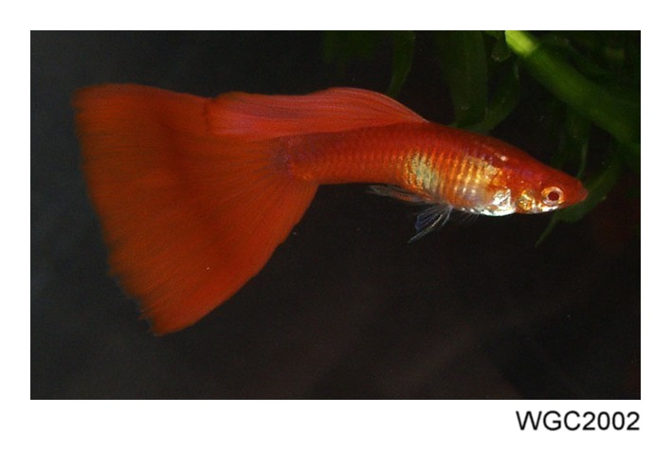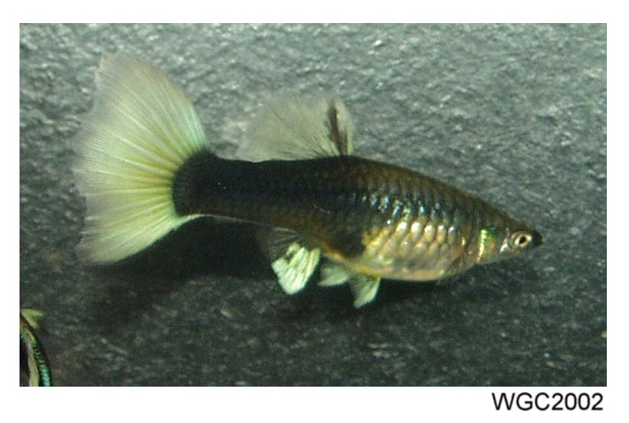
International Fancy Guppy Association

Proudly hosts the 2020 IFGA Annual 74 Class Guppy Show,
Awards Banquet and Auction

Show Event Friday, October 9th @ 9:00 AM/1:00 PM
Schedule: Breeding/Judging Seminars (free admission)
Saturday, October 10th
Closed to the public
Sunday, October 11th @ 8:00 AM
Viewing and Auction (free admission)

Heron Point Office Building (lower level)
645 W. North Ave.
Lombard, IL 60148

(The office building is adjacent to the Fairfield Inn - just east of I-355 at the corner of Route 53
and North Ave/Route 64 - enter via Heron Point Drive which is located 1 block south of
Route 64 on Route 53).

The Friday Seminars (no admission charge) will begin at 9:00 AM and conclude with the
official IFGA Judging Seminar beginning at 1:00 PM.

The Exhibition Hall (lower level) will be open for public viewing on Sunday from 8:00 AM until
10:00 AM (no admission charge) prior to the auction.

The Official show rules can be found in the Show Section at www.ifga.org –
guppies will be accepted for the competition on Friday/Saturday only.
Judging is on Saturday by IFGA Standards.

A public auction of fancy show guppies starts at 10:00 AM
Sunday and continues until all auction fish are sold.

For more information call (847) 222-9781.

